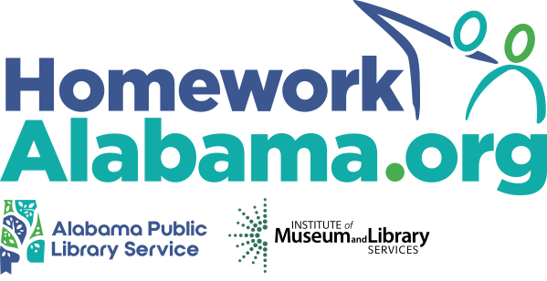 **PRESS  
GUIDE**

**Ideas & Sample Articles to  
Promote the Service in Your Community**

Social media is a great way to stay connected with current patrons. But how do you reach those who are unaware of the library and its resources? Try your local newspaper!

An engaging article published by your community’s local news source—online and in print—generates interest and increases awareness of your library's great services. Moreover, articles give you the space to get into the nitty gritty of your offerings and they have a wider reach than a [flyer or poster](https://tutor.com/homework-alabama/librarian-resources) does (though we encourage posting those in your library and around town, too!).

Whether you are submitting an article to be published or contacting a reporter to generate a story, utilizing the local press will help to widen your library’s reach in the community. To help you get started and to inspire some ideas, we have provided some suggested topics for articles and examples that other libraries have used in the past. Read on!

**Headlines and Topics:**

* **“Stuck on a problem? Need homework help? Get to your library—online!”**

Write about the launch of your Homework Alabama program.

* **“Get ready for back-to-school time with free resources from your library”**

Submit an article summarizing the back-to-school resources your library provides to families in your community—including access to free expert support from Homework Alabama.

* **“Don’t break your back-to-school budget. Use FREE library resources!”**

Summarize how accessing homework help resources can help refresh students’ minds—totally free of cost.

* **“Prepare for the [SAT®/GRE®/etc.] — FREE from your library!”**

Just ahead of ahead of testing periods and around midterms and finals, recap the test prep and study resources you have available for all learners, including FREE expert tutoring, writing help, Digital SAT®/ACT® Essentials, and graduate program test prep from Homework Alabama.

* **“FREE library resources you can use from home”**

Outline the digital resources that patrons can use from the comfort of their home, including access to free expert tutoring and homework support from Homework Alabama.

* **“Get help on your college application with FREE library services”**

Create an article that lists the different services available for students applying to college. Whether it's research help or essay writing, Homework Alabama has the help learners need.

* **“Looking for FREE career help? Look no further than your library!”**

Help recent graduates or those looking for a new career by sharing information about the career services your library has to offer.