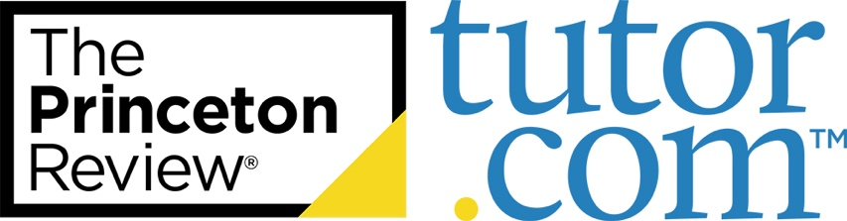

**PRESS  
GUIDE**

**Ideas & Sample Articles to  
Promote the Service in Your Community**

Questions? Comments?  
[clientsupport@tutor.com](mailto:clientsupport@tutor.com)

Press Guide: Ideas & Sample Articles for Libraries

Social media is a great way to stay connected with current patrons. But how do you reach those who are unaware of the library and its resources? Try your local newspaper!

An engaging article published by your community’s local news source—online and in print—generates interest and increases awareness of your library's great services. Moreover, articles give you the space to get into the nitty gritty of your offerings and they have a wider reach than a [flyer or poster](https://www.tutor.com/prc/libraries) does (though we encourage posting those in your library and around town, too!).

Whether you are submitting an article to be published or contacting a reporter to generate a story, utilizing the local press will help to widen your library’s reach in the community. To help you get started and to inspire some ideas, we have provided some suggested topics for articles and examples that other libraries have used in the past. Read on!

**Headlines and Topics:**

* **“Stuck on a problem? Need homework help? Get to your library—online!”**

Write about the launch of your program.

* **“Get ready for back-to-school time with free resources from your library”**

Submit an article summarizing the back-to-school resources your library provides to families in your community—including access to free expert support from Tutor.com.

* **“Don’t break your back-to-school budget. Use FREE library resources!”**

Summarize how accessing free resources can help refresh students’ minds—totally free of cost.

* **“Prepare for the [SAT®/GRE®/etc.] — FREE from your library!”**

Just ahead of ahead of testing periods and around midterms and finals, recap the test prep and study resources you have available for all learners, including FREE expert tutoring, writing help, SAT®/ACT® Essentials, and graduate program test prep from Tutor.com and The Princeton Review.®

* **“FREE library resources you can use from home”**

Outline the digital resources that patrons can use from the comfort of their home, including access to free expert tutoring and homework support from your program.

* **“Get help on your college application with FREE library services”**

Create an article that lists the different services available for students applying to college. Whether it's research help or essay writing, Tutor.com has the help learners need.

* **“Looking for FREE career help? Look no further than your library!”**

Help recent graduates or those looking for a new career by sharing information about the career services your library has to offer.

# **About Tutor.com**

Tutor.com is the world's largest and highest-rated online learning service. Since 2000, the Tutor.com community of more than 4,000 highly vetted expert tutors has delivered close to 27 million tutoring and professional development sessions in a modern online class-room optimized for learning. Tutor.com powers tutoring and homework help programs for thousands of public libraries, school districts, colleges and universities across the country. For more information, please visit [tutor.com/libraries.](http://www.tutor.com/libraries)

# [**Published Examples**](http://www.houmatoday.com/article/20121106/ARTICLES/121109805/-1/opinion?Title=Need-homework-help-Use-your-local-library-8217-s-online-programs)

# ***Find more*** [***here***](https://www.tutor.com/press-center#mediaMentions)***.***

# **West Virginia Gov. Justice announces statewide partnership with Tutor.com**

# <https://governor.wv.gov/News/press-releases/2023/Pages/Gov.-Justice-announces-statewide-partnership-with-Tutor.com.aspx>

# Gov. Jim Justice announces that West Virginia has entered into a partnership with Tutor.com to provide expert online tutoring, test prep, and job support for West Virginia public library patrons across the state through a new program: TutorWV. The program is accessible via a dedicated website TutorWV.com.

# **Tutor.com Delivers More than 10,000 New Hampshire Sessions Through NHED Partnership**

# <https://www.tutor.com/press/press-releases-2024/20240304>

# Tutor.com, one of the world's largest and most innovative online tutoring organizations, announced that it had served 11,592 sessions through its partnership with the New Hampshire Department of Education (NHED).

# Through this program—which launched in fall 2022 serving grades 6–12 and recently expanded to serve grades 4–5 and adult learners—students can access 24/7 expert tutoring

# w

# **Clovis Unified aims to help students with homework by providing 24/7 support from Tutor.com**

# <https://abc30.com/clovis-unified-tutor-website-student-support-homework/14363312/>

# Clovis Unified School District is making sure students have added support with homework.

# Live tutoring is available for all students 24 hours a day, seven days a week, free of charge.

# It's helping students power through when their teachers aren't available.

# "We really felt like were missing the opportunity to help students at home whether it's before dinner time, after dinner time," Clovis Unified Director of Supplemental Service Robyn Snyder said.